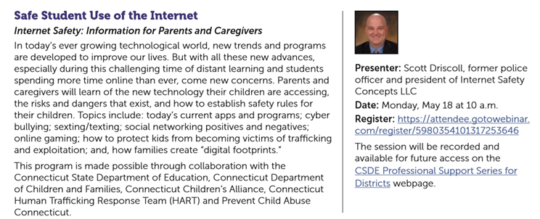

Click here to register:

<https://attendee.gotowebinar.com/register/5980354101317253646>